KALAGURU BISHNU RABHA DEGREE COLLEGE

ORANG, UDALGURI, BTR, ASSAM

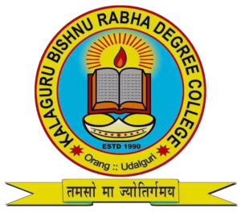

PROSPECTUS

ACADEMIC SESSION-2025-2026

Published by - Kalaguru Bishnu Rabha Degree College, Orang ,Udalguri

About the College:

The college takes its inspiration form the famous lines of the song ' Biswar Sande Sande Mahandande Anande' written by Kalaguru Bishnu Prasad Rabha, the mentor of Assamese society and a leader of the common people -

জ্বলোৱা সাগ্নিক তপ হোম বহ্নি

বিনাশক এন্ধাৰ তবজয়ী অগ্নি

বিশ্বৰে দেউলত জ্ঞানৰে বন্তিৰ

আলোকৰে শিখা উঠক নাচি

অজ্ঞান এন্ধাৰ বিনাশি

A higher educational institution was established in the heart of Orang Chariali in 1990 by some of the economically weak but ever conscious and far sighted people of Orang with the help of public donations in the name of revered personality of Assam, Bishnu Prasad Rabha, who is regarded as the mentor of culture and father of socio-economic revolution in Assam.The Kalaguru Bishnu Rabha Degree College has emerged as one of the leading educational institution imparting higher education to thousands of students belonging to different caste and communities and specially the Tribal and Non-Tribals covering the vast area of the undivided Darrang as well as neighbouring Sonitpur District. The college was in a venture stage till 31st December 2020 and was brought under the category of Provincialization by Government of Assam with effect from 01-01-2021. Till then,it was fully managed by the Governing Body . Despite several economical and social challenges, the college is rendering its valuable service in the field of education to the poor and needy students as the area it covers is mostly economically and geographically backward ranging from Indo-Bhutan, Assam-Arunachal Pradesh Border in the North to the Char-Chapari area in South. The College is making a rapid progress in the academic field with better performance of the students in the subsequent examinations held by affiliating University. It tends to be economically self-sufficient and literally a full-fledged institution by dint of its competent staff. The College is accredited with ‘B’ Grade by National Accreditation and Assessment Council( NAAC) in its first Cycle of Assessment held in 2023 and has a vision and mission to rise its level to the utmost level in the forthcoming years.

Motto of the College: ‘Teach Them to Live’

Vision of the College:

- To impart modern knowledge, develop skill, inculcating proper values of life, infusing desired attitude towards society and forming relationship between mind and soul.
- To give quality education and maximum educational facilities to the poor and needy students of the area with minimum cost.
- To build expert and qualified graduates with sound knowledge of their core discipline and to produce work forces having self-determination and the ability to explore opportunities.
- To enhance self-confidence and leadership and leadership qualities of the students to face present day challenges and risks and to develop in them independent thinking, creativity, innovative mindset and decision taking capacity.
- To motivate students to dream, believe and achieve.
- To create a brand image ‘KALAGURU BISHNU RABHA DEGREE COLLEGE.

Mission of the College:

- The college has a mission to uplift the socially and economically backward society through education and make them capable of living with dignity.
- To infuse the competitive mentality among the students and to prepare them for various competitive examinations.
- To motivate the students to love the mother earth and inculcate in them the uderstanding of the environment and our eco-system so as to preserve it in the best possible ways.
- To develop among the students and teachers a bonding of understanding and care.
- To help the students achieve their cherished goals by facilitating them with the best educational environment and best technology for availing teaching learning facilities.
- To develop the college as a complete Green Zone.
- To develop the college into an exemplary institution of social equality and place of communal harmony.
- To develop the college into a higher educational institution of application oriented curriculum.
- To develop an environment for the involvement of faculty members to actively extend their co- operation in teaching learning process beyond the classroom for the holistic development of the student fraternity as a whole.
- To establish the college as a brand of quality education and equity in all forms.

GENERAL INFORMATION ABOUT THE COLLEGE:

- KALAGURU BISHNU RABHA DEGREE COLLEGE was estbalished in the year 1990 and was Provincialized by Government of Assam w.e.f. 01-01-2021.

- The College is affiliated to Bodoland University, Kokrajhar.

- The College is accredited with Grade-B by National Accreditation and Assessment Council( NAAC) in its 1st Cycle.

- The College is registered under Societies Registration Act XXI of 1860 and recognized by University Grants Commission, New Delhi under Section 2(f) and 12(B) of the UGC Act,1956.

- The College offers Four Year Undergraduate Courses in the Faculty of Arts, Humanities and Social Sciences with MAJOR and MINOR Disciplines of B.U syllabus under the National Education Policy-2020 Curriculum in Regular Mode.

- The College also offers Undergraduate and Post Graduate Courses under Krishna Kanta Handiqui State Open University in Distance Mode.

- The College is a Local Chapter under SWAYAM-NPTEL Platform and offers all the Free Courses offered by SWAYAM-NPTEL.

- For any further information regarding the various aspects of the College , students are requested to visit the official website: www.kbrdcollege.ac.in

- The medium of instruction in the College is both Assamese and English medium.

IMPORTANT DATES:

Date of opening of Samarth Portal for Registration-

4th April,2025

https:// www.assamadmission.samarth.ac.in
Date of Online Submission of Forms : To be Notified Soon

Last date of Online Submission of Forms :

To be Notified Soon

Admission will be granted only to those students who have registered in SAMARTH PORTAL and will be considered purely on MERIT BASIS.

No Direct admission will be entertained to any student and selection will be made on the basis of prescribed norms and rules framed by Director of Higher Education, Government of Assam.The Dates notifed in the Samarth Portal by Government of Assam will be strictly followed and therefore all the students are requested to keep themselves updated throughout the process of Admission.

TIME SCHEDULE FOR PUBLICATION OF MERIT LIST BY THE COLLEGE

Date of Publication of 1st Merit List- To be Notified Soon
Last Date of Admission of Selected Candidates in 1st Merit List - To be Notified Soon
Date of Publication of 2nd Merit List- To be Notified Soon
Last date of Admission of Selected Candidates in 2nd Merit List-
To be Notified Soon
Date of Publication of 3rd Merit List- To be Notified Soon
Last Date of Admission of Selected Candidates in 3rd Merit List - To be Notified Soon
(N.B-Provision of 2nd & 3rd Merit List is subject to the availability of Seats)
•

FEE STRUCTURE

Admission Fee- Rs. 7180/-
( As per Notification of Director of Higher Education Assam-2024-25)

(N.B-Government of Assam Fee Waiver Scheme applicable for all eligible candidates who can produce Income Certificate of less than 4.00 Lakhs issued by Revenue Circle officer or Ration Card ).

Admission Fee under Fee Waiver Scheme-
Rs. NIL

As per National Education Policy-2020 a student can acquire the following Degrees -

- CERTIFICATE -
If completed 2( Two) Semesters with 40 +4 Credits
- DIPLOMA
If completed 4( Four) Semesters with 80+4 Credits
- BACHELOR DEGREE
If completed 6( Six) Semesters with 120 Credits
- DEGREE WITH HONOURS AND RESERACH
If completed 8( Eight) Semesters with 160 Credit

PHYSICAL FACILITIES AVAILABLE IN THE COLLEGE:

- RFID BASED DIGITAL LIBRARY-

The Library of Kalaguru Bishnu Rabha Degree College is RFID Based Digital Library that makes the access of books for the students easier and quicker and has around 17070 books and 53 peer reviewed journals and subscribed magazines apart from access to around 2 lakhs books in N-List.The library has both text books and reference books in different languages.
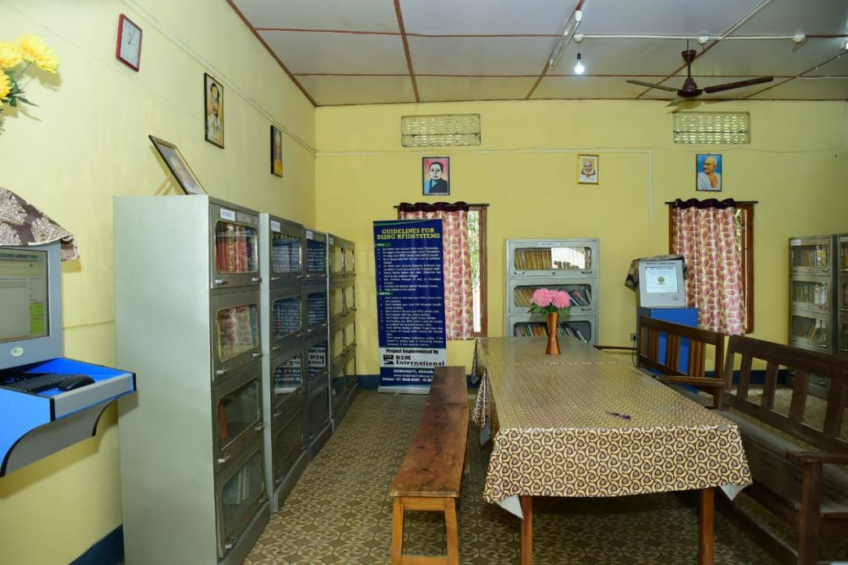
- PSYCHOLOGICAL LABORATORY:

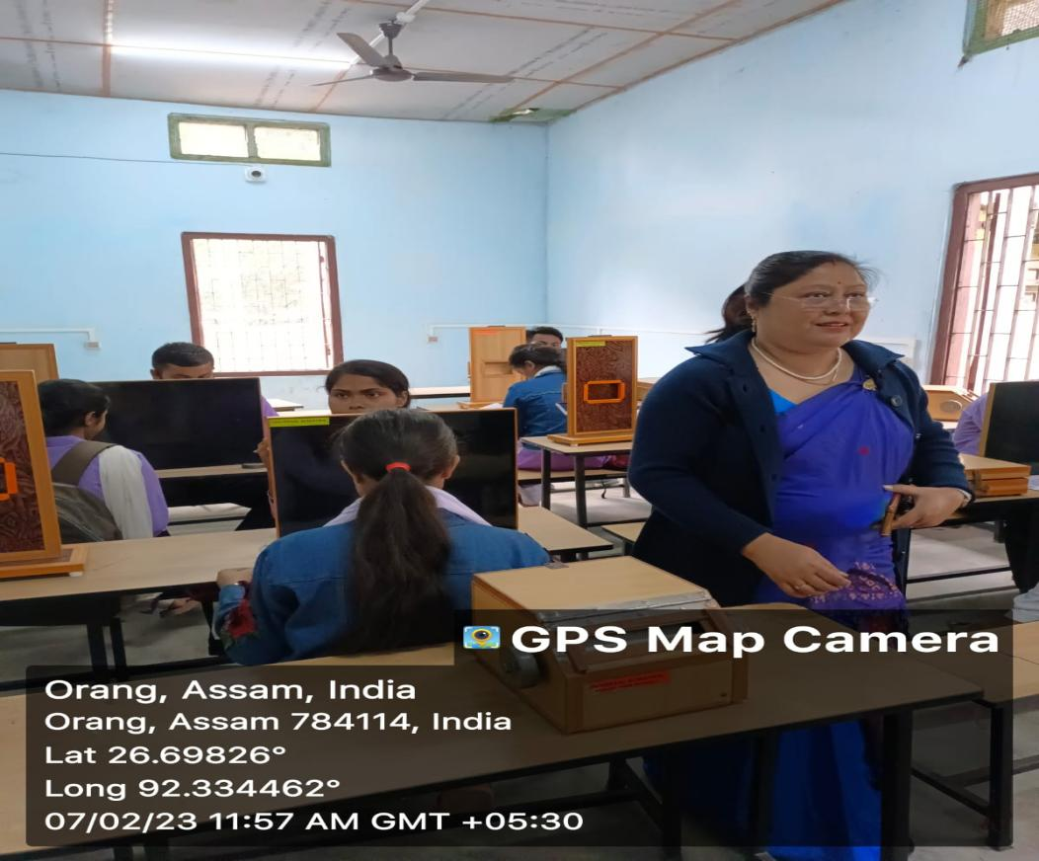
The College has a well-equipped psychological laboratory for facilitating the students of Education.
- ICT ENABLED CLASSROOMS:

The college has already introduced the ICT enabled Classrooms and upgraded many of its classrooms to ICT enabled. The faculty members of the college also use additional resources from internet using their mobile technology to help the students.The College has already introduced ICT based classrooms.

- LANGUAGE LABORATORY:

The college has already set up a Language Laboratory with the help of BTR Government from the Session 2024-2025 for the students to acquire practical knowledge on Spoken English and other languages .

- COMPUTER AND INTERNET FACILITIES:

The college offers 6 Months Certificate Course on Computer Applications and has a separate computer lab for the student learners with around 15 computers for practical classes with a seating arrangement for 30 students in Theory classes.It also has ISP BSNL Broadband Connection in the College with 10MBPS permanent internet facility.

- SANITATION
The College has separate Sanitation Facilities for Male and Female Students & Teaching -Non-Teaching Staff.

- DRINKING WATER FACILITIES
The College provides pure drinking water facilities for its students.It also has implanted pure cold drinking water facilities for its students as well as Teaching and Non-Teaching.

- KALAGURU BISHNU RABHA DEGREE COLLEGE OUTDOOR STADIUM:

The College has a separate Outdoor Stadium for facilitationg students with various games and sports events constructed from the UGC allocation of fund covering an area of more than 4 Acres of Land.

- KALAGURU BISHNU RABHA DEGREE COLLEGE INDOOR STADIUM:

The College has an Indoor Stadium constructed within the College campus and indoor sports facilities constructed from the UGC allocation of fund.

- KALAGURU BISHNU RABHA DEGREE COLLEGE GYMNASIUM

The college also has a well-built gymnasium inside the Indoor Stadium that facilitates both the students and staff of the college.

- SOLAR POWER ENERGY

The College has a well mainatined and fully functional solar power energy supply for 24 hours established in the College campus.

- COMPUTER LAB
The college has a separate computer Lab to carry out computer courses for the students. The College offers 6 Months Certificate Course on Computer Application.

- K.B.R DEGREE COLLEGE GIRLS’ HOSTEL
The College has a women Hostel with all basic facilities for the students with an intake capacity of 60 students.

- K.B.R DEGREE COLLEGE BOYS’ HOSTEL

The College has a Boys’ Hostel with all basic facilities for the students with an intake capacity of 30 students.

COURSES AVAILABLE IN THE COLLEGE

REGULAR MODE
FOUR-YEARS UNDERGRADUATE PROGRAMME(FYUGP)
DISTANCE MODE
UNDERGRADUATE AND POST-GRADUATE COURSES UNDER K.K HANDIQUI STATE OPEN UNIVERSIITY

REGULAR MODE
- FYUGP WITH ONE MAJOR AND ONE MINOR
- FYUGP WITH TWO MINOR

MAJOR SUBJECTS ( 4 CREDITS) & SEATS AVAILABLE
•ASSAMESE -50 Seats
•BODO - 50 Seats
•ENGLISH -40 Seats
•EDUCATION -40 Seats
•ECONOMICS -40 Seats
•HISTORY -40 Seats
•NEPALI - 40 Seats
•POLITICAL SCIENCE - 50 Seats

MINOR SUBJECTS ( 4 CREDITS) & SEATS AVAILABLE
- ASSAMESE ( 90 Seats)
- BENGALI ( 30 Seats)
- BODO (60 Seats)
- ECONOMICS ( 50 Seats)
- EDUCATION (140 Seats)
- ENGLISH ( 70 Seats)
- FOLKLORE (30 Seats)
- HISTORY ( 100 Seats)
- NEPALI (30 Seats)
- PHILOSOPHY (60 Seats)
- POLITICAL SCIENCE (140 Seats)

- CERTIFICATE COURSE IN SPOKEN ENGLISH- 15 STUDENTS PER BATCH
- CERTIFICATE COURSE IN COMPUTER APPLICATIONS-15 STUDENTS PER BATCH
( Reservation of Seats for Major Courses in each subject for SC/ ST/OBC/PWD and as a whole for General Course( Two Minor) will be applicable as per the Reservation Policy notified by Government of Assam).

SUBJECTS TO BE SELECTED BY THE STUDENTS OPTING FYUGP WITH ONE MAJOR -ONE MINOR CURRICULUM
FOR ONE MAJOR-ONE MINOR CURRICULUM( MAJOR COURSE) -
Please select -ONE MAJOR SUBJECT from GROUP A & ONE MINOR SUBJECT from GROUP-B
GROUP-A | GROUP-B
ASSAMESE | ASSAMESE
BODO | BENGALI
ECONOMICS | BODO
EDUCATION | ECONOMICS
ENGLISH | EDUCATION
HISTORY | ENGLISH
NEPALI | FOLKLORE
POLITICAL SCIENCE | HISTORY
 | NEPALI
 | PHILOSOPHY
 | POLITICAL SCIENCE

(N.B- STUDENTS CANNOT SELECT SAME MAJOR AND MINOR SUBJECT)

OR STUDENTS OPTING TWO MINOR CURRICULUM( GENERAL COURSE)
Please select TWO MINOR SUBJECTS from either GROUP-A /GROUP-B / GROUP-C / GROUP -D
GROUP-A | GROUP-B | GROUP-C | GROUP-D
ASSAMESE | ASSAMESE | ASSAMESE | ASSAMESE
BENGALI | BENGALI | BENGALI | BENGALI
BODO | BODO | BODO | BODO
ECONOMICS | ECONOMICS | ECONOMICS | ECONOMICS
EDUCATION | ENGLISH | ENGLISH | ENGLISH
ENGLISH | HISTORY | FOLKLORE | FOLKLORE
HISTORY | NEPALI | HISTORY | HISTORY
NEPALI | PHILOSOPHY | NEPALI | NEPALI
PHILOSOPHY | POLITICAL SCIENCE | POLITICAL SCIENCE | EDUCATION

COMPULSORY SUBJECTS( FOR STUDENTS OPTING BOTH ONE-MAJOR -ONE MINOR CURRICULUM OR TWO MINOR CURRICULUM( GENERAL COURSE) -

ABILITY ENHANCEMENT COMMUNICATION (AEC) -2 CREDITS

SELECT ANY ONE
- ASSAMESE
- ENGLISH
- BENGALI
- BODO
- NEPALI
SELECT ONE SUBJECT FROM EACH GROUP:

SL. NO | NAME OF SUBJECT | CREDITS | SUBJECTS AVAILABLE FOR SELECTION
1. | INTER-DISCIPLINARY SUBJECT( IDC) | 3 Credits | MOOCS( ONLINE SOURCE PROVIDED BY THE COLLEGE)
2. | SKILL ENHANCEMENT COURSE (SEC) | 3Credits | ASSAMESE,BENGALI,BODO, ECONOMICS,EDUCATION, ENGLISH,HISTORY,NEPALI, POLITICAL SCIENCE
3. | VALUE-ADDED COURSE( VAC) | 4 Credits | BODO,ECONOMICS, EDUCATION, ENGLISH, POLITICAL SCIENCE

Documents to be Submitted in the College at the time of Admission:
- Photostat copies of HSLC Registration, Mark Sheet & Certificate (One copy each).
- Photostat copies of HS Registration, Mark Sheet & Certificate (Two copies each).
- Caste Certificate for SC/ST/OBC candidates.(If any)
- One copy of Passport size photograph (one copy black and white photograph)
- 3 copies of Photostat copy of AADHAR & PAN Card
- Photostat copy of Front Page of Students’s Bank Passbook.
- Income Certificate Issued by Revenue Circle Officer / Ration Card issued by competent authority for students seeking Fee Waiver.

TEACHING AND NON-TEACHING STAFF OF THE COLLEGE
Principal
Dr. Utpal Chandra Hajong, M.A,M.PHIL, Ph.D
Vice-Principal
Dr. Dhruba Jyoti Sarmah, M.A, Ph.D

Department of Assamese

- Mrs. Bichitra Bala Nath, M.A, NET
Assistant Professor

- Mrs. Nilakshi Keot, M.A
Head & Assistant Professor

- Mrs. Gitanjali Deka,M.A
Assistant Professor

- Miss Subhalakshmi Das, MA,SLET
Assistant Professor( Contractual)

Department of Bengali

- Mr. Pankaj Deb,M.A
Head & Assistant Professor

- Mr. Bidyut Saha,M.A
Assistant Professor( Contractual)

Department of Bodo

- Mr. Ripson Daimary, MA, SLET
Assistant Professor

- Mrs. Helen Daimari, M.A,NET, B.Ed.
Head & Assistant Professor

- Mrs Hangmashri Daimary,M.A, B.Ed.
Assistant Professor( Contractual)

Department of Economics

- Mr. Binod Basnet, M.A
Assistant Professor

- Mr. Rinku Haloi, M.A, M.PHIL, NET,SLET
Head & Assistant Professor

- Miss Parishmita Baishya,M.A
Assistant Professor( Contractual)

Department of Education

- Mrs. Trishna Das, M.A, B.Ed.
Assistant Professor

- Md. Insaf Ali, M.A, NET
Head & Assistant Professor

- Mr. Sankar Baro,M.A
Assistant Professor( Contractual)

- Mr. Arjun Swargiary, MA, NET
Assistant Professor(Contractual)

Department of English

- Dr. Ramesh Dahal, MA(ENG, POL. SCIENCE), NET, Ph.D
Assistant Professor

- Dr. Homen Baruah, M.A, M.PHIL, NET,SLET,Ph.D
Head & Assistant Professor

- Dr. Purnima Boro, M.A, M.PHIL, NET, Ph.D
Assistant professor

Department of Folklore

Dr. Julie Duwarah, M.A, NET, Ph.D
Assistant Professor(Contractual)

Department of History

- Dr. Dhruba Jyoti Sarmah, M.A, Ph.D
Vice-Principal
- Dr. Bishnu Chetry, M.A, B.Ed., Ph.D
Head & Assistant Professor

- Miss Bhanumati Basumatary, M.A
Assistant Professor( Contractual)

Department of Nepali

- Mr. Tirtha Raj Phayel,M.A, NET
Assistant Professor

- Mr. Narayan Chandra Upadhyaya,M.A, NET
Head & Assistant Professor

- Mr Kishor Nirola, M.A
Assistant Professor( Contractual)

Department of Philosophy

Mrs. Chandipa Kalita Mahanta,M.A
Incharge/ Assistant Professor( Contractual)

Department of Political Science

- Mr. Indra Borah, M.A, M.PHIL
Assistant Professor

2.Mr. Malin Chandra Biswas, M.A, LLB, NET
Head & Assistant Professor

- Md. Asab Uddin Ahmed, MA, LLB
Assistant Professor

- Miss Sushma Devi,M.A
Assistant Professor( Contractual)
Librarian
Mrs Hemalata Bhattarai, B.A,M.L.I.Sc
Library Assistant
Mr Binoy Mochahary,M.A
Mr. Hemanta Das,B.A ( Contractual)
Upper Division Assistant( UDA)
Mr Bhaskar Kachari, B.A
Mr.Nabakanta Deka, M.A
Lower Division Assistant(LDA)
Mr Elias Basumtary, M.A
Mr. Dipak Hajong, B.A
Mr. Homeswar Das,M.A
Mr. Rajib Gautam, M.A
Grade-IV
Mr. Chandra Kanta Sarmah
Mr. Jiten Kachari
Mr. Ajit Baishya
Mr. Mwnsai Basumatary
Mr. Prafulla Rabha
Mr. Prabin Mahatoo
Mr. Raben Basumatary
Mrs. Sheila Mahatoo( Contractual)

Please contact FOR FURTHER INFORMATION REGARDING FYUGP 1ST SEMESTER ADMISSION-2025-2026:

PRINCIPAL
DR. UTPAL CHANDRA HAJONG
Mobile No- 7002182204
SAMARTH NODAL OFFICER
MR. RINKU HALOI, ASSISTANT PROFESSOR
Mobile No- 8876581492

ADMISSION NODAL OFFICER
DR. DHRUBA JYOTI SARMAH
VICE- PRINCIPAL
Mobile No- 9954724856

