KALAGURU BISHNU RABHA DEGREE COLLEGE

ORANG, UDALGURI, BTR, ASSAM

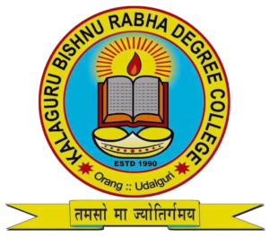

GUIDELINE FOR SPOT ADMISSION

ACADEMIC SESSION-2025-2026

GUIDELINES FOR SPOT ADMISSION FOR THE SESSION
2025-2026

- Admisson will be granted purely on First Cum First Serve Basis.

- The students of the fringe village, local area, adopted village will be given preference.

- Candidate with proper Merit Score will be preferred.

- Candidates with special Extra Curricular and Co-Curricular Activities will be considered under special provision.

PRINCIPAL
DR. UTPAL CHANDRA HAJONG
Mobile No- 7002182204
SAMARTH NODAL OFFICER
MR. RINKU HALOI, ASSISTANT PROFESSOR
Mobile No- 8876581492

ADMISSION NODAL OFFICER
DR. DHRUBA JYOTI SARMAH
VICE- PRINCIPAL
Mobile No- 9954724856

Helpline Numbers:
Dr. Ramesh Dahal
Mobile No- 8638972397

Dr. Homen Baruah
Mobile No-7002029982

